BEAUTY, BOOZE AND BOCCE AT BETTY’S BEACH, W.A.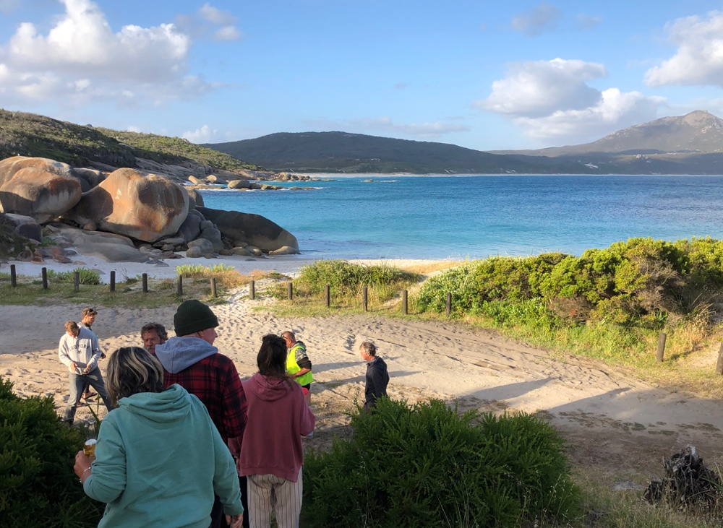

I had to try free camp, Betty’s Beach, in SW of Western Australia as a nurturing grey nomad had recommended it. Across the north, free camping at Camooweal Billabong and Mary Ponds was a dusty, dry experience – stunning locations in their own way – and you can’t grizzle about a campsite that costs you nothing. And on the way through the Northern Territory we had stayed in a few back-of-roadhouse locations at minimal expense ($10 or so a night).

So Betty’s Beach it was to be for a few days to give low cost camps a go. I loaded up with water so I could use my “Kick Ass” shower each night and knew my solar panels would drive my fridge and lights. No connectivity was a nice change and family were alerted I would be out of range for a while. Drop toilets were the only facilities.

What a stunning location! A very steep gravel road into the site opened up to a breathtaking view. Azure blue water lapped the white sands of two tiny bays, each separated by large, smooth, tan boulders but connected by a pathway. Dotted across the beaches on small sandhills were a number of fishing huts used by salmon fishermen during the season when the beach is closed to campers. Immediately upon arrival, I decided that this free camp would do me for a number of nights

.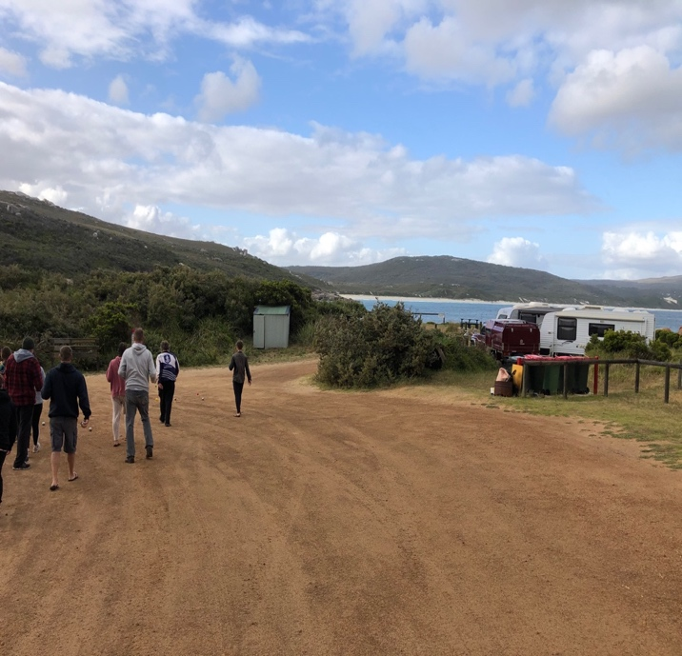 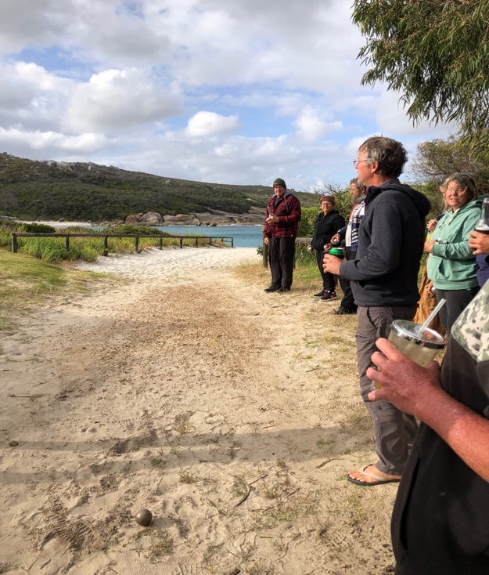

Camp hosts, Scott and Margaret, welcomed me and seemed keen on chatting while I set up. I was asked if I liked bocce and said “Sure!”. Any diversion from campsite reading, navel contemplation, etc. was welcome.

So, at 4pm all the happy campers at this beautiful place appeared, glass in hand, for the routine bocce game. No courts here – the red ball was pitched in all directions: up the hill, down the hill, down the sandy track towards the beach, across corrugations named the lunar landscape, into the tall bushes of Snake Gully and towards the toilet if the thrower needed to visit the drop toilets during the game or via an individual’s campsite if a refill was needed.
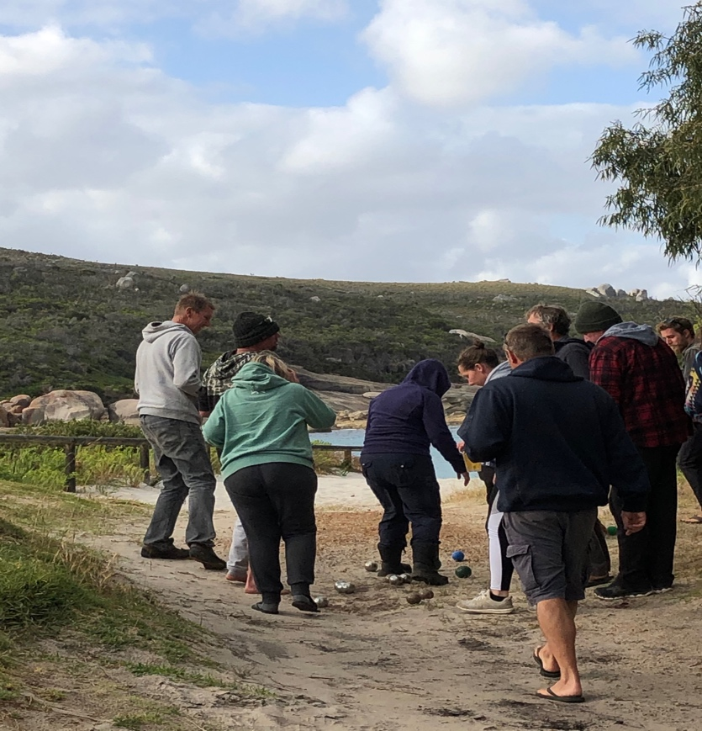
This variation on happy hour was original and fun. Grey nomads mixed with European backpackers and the bocce organiser, Carey, appeared each afternoon with his “cocktail” of “any wine under $10, a splash of Fanta and vodka” encased in a tall plastic cup with a straw. Following this forty eight year old camper with a mohawk was his twenty three year old girlfriend. He parked his camper bus alongside one of the fishing huts and had connections with the fisherman who owned the hut so each night he lit a small brassier fire in the hut and welcomed other campers.

The bocce flock met the next day with pseudo competitive spirit, but rain kept players away on the third afternoon and some left to continue their travels.

Free camps attracts free spirits who are convivial and willing to have a go. I will try the next one on my list and welcome a change from homogeneous caravan parks unless I really have a need for water, power and washing.

